Science
Fair Packet III

Display Board

- I have received and read Science Fair Packet II.

Parent Signature Date

Student Signature Printed Student Name

Tips for Creating Outstanding Displays

Be Neat
Avoid frayed or ripped edges of paper, glue globs, lots of cross outs or white outs etc.

Color and Texture
Typically, it is recommended not to use more than 3 colors. Too much color can be distracting. Instead develop a color pallet that is eye pleasing.

Frame or Matte Your Work
Use construction paper or other colored materials to provide a background for your work you will be displaying

A Short, Catchy, Related Title
Use your Language Arts skills here to find just the right title for your project. Draw
or cut out letters that clearly show your project title and arrange them on the side or at the top of your backboard.

Writing Should be Neat and Legible
It is recommended that you type your work to be displayed. If you do, don’t use fonts which are too hard to read and don’t use too many different fonts. Use spell check!! If you are handwriting your work, print or use cursive, don’t mix the two. Be extra careful to write so that others can easily read your information.

Spelling Does Count
Take time to check over our work. Don’t overuse whiteout. Scratching out mistakes is not acceptable. If you do recognize an error after finishing, place a single line through it and write the corrected word above. However, too many of these types of marks will affect the overall appeal of your project.

Practice Your Layout
Don’t glue thing down until after you have placed display items in their spot and you can see how they look together. Make sure they are evenly spaced and level. Once you have a layout that looks eye pleasing, then glue down the items.

Don’t Glue on Object From Your Project
Don’t glue on food items such as M&M’s, popcorn, or Skittles. Food products attract bugs and so do their wrappers.

Data

Use graphs to summarize your project data. Be sure to have your raw data in a folder on the table in case someone wants to see exactly what you did. Be sure to include your project journal on the table in front of your backboard.

Project Abstract
Write up an abstract. This should be four paragraphs that a passersby can read to understand the general ideas you worked on for your project.

Photographs/Charts/Tables
Photographs that you have taken during your project are good addition, but remember any picture, chart, or data table has to be cited to give credit to who created it. It’s ok if you end up citing yourself. Read over the rules for using photographs/graphs/charts (next page).

Models
If you have made a model for your project, it should be placed on the table in front of your backboard. It should be clearly labeled so visitors will know what they are looking at and why.

Research Reports
Don’t attach the report to the display. It is placed in front of the display with the data log book.

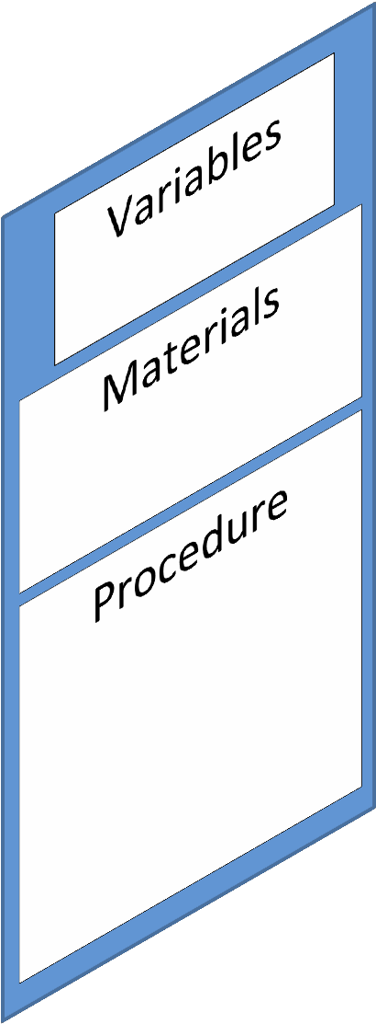
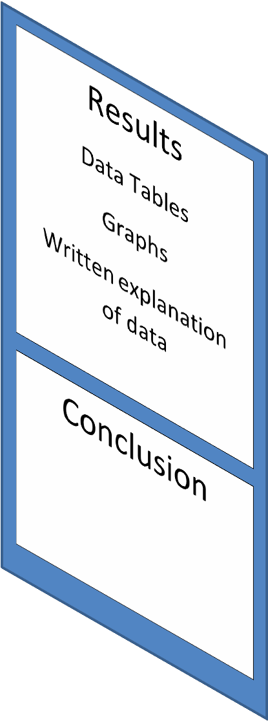
Sample Science Fair Display Board Name/School
information on
the back of this flap
Title
Question
Hypothesis

Official
Abstract
Form
Pictures,
Photos,
Drawing

Science Fair boards need to be at least 36” x 48”
(up to a maximum size of 48” wide and 108” high from the floor and 30“ deep)

Photograph/Image Display Requirements
Display of photographs other than that of the finalist must have a photo release signed by the subject, and if under 18 years of age, also by the guardian of the subject. Sample consent text: “I consent to the use of visual images (photos, videos, etc.) involving my participation/my child’s participation in this research.”

Any photograph/visual image/chart/table and/or graph is allowed if:
- It is not deemed offensive or inappropriate (which includes images/photographs showing invertebrate or vertebrate animals/humans in surgical, necrotizing or dissection situations) by the Scientific Review Committee, the Display and Safety Committee, or Society for Science & the Public. The decision made by any one of the groups mentioned above is final.
- It has a credit line of origin (“Photograph taken by...,”or “Image taken from...,” or “Graph/Chart/Table taken from. . . .”). (If all images, etc. being displayed were taken or created by the finalist or are from the same source, one credit line prominently and vertically displayed on the backboard/poster or tabletop is sufficient.)
- It is from the Internet, magazine, newspaper, journal, etc., and a credit line is attached. (If all photographs, etc. are from the same source, one credit prominently and vertically displayed is sufficient.)
- It is a photograph or visual depiction of the finalist.
- It is a photograph or visual depiction for which a signed consent form is at the projector in the booth.
Note: Images used as backgrounds must also be credited.

All photos/visuals/charts/tables/graphs etc. need a credit line of origin, even if you
credit yourself

Tips for a Successful Presentation
- Be able to discuss your independent and dependent variables as well as your controls and constants– make sure they are defined correctly and you understand their importance in your experiment

- Do some background research about your topic BEFORE YOU START YOUR EXPERIMENT so you can discuss with the judges what you learned about your topic that helped you understand what is happening in your experiment

- Understand and be able to communicate how/why the information you learned from your experiment is important

- Cite your photos and graphs/charts if you have pictures, you need to cite on your board who took the pictures. For example: “Pictures were taken by Billy Bob Thompson.” Also, if you have any graph or chart, you will need to do the same. For example: “Chart and Graphs created by Sally Sue Martin.” If you took the pictures or you created the chart/graphs, then use your name!!!!

Final Report Checklist

o | Does your abstract include a short summary of the hypothesis, materials and procedures, results, and conclusion?
o | Have you used proper capitalization and punctuation?
o | Have you checked for grammar and spelling?
o | Does your final report include the following key sections:
o | - Title page
o | - Table of Contents
o | - Background Research (Introduction)
o | - Question
o | - Hypothesis
o | - Variables, Constants, and Controls
o | - Materials
o | - Procedure (Method)
o | - Results
o | - Discussion (lab conclusion)
o | - Conclusion (of entire paper)
o | - Bibliography
o | - Abstract

