Sample

Research

Paper

What is the Effect of Thermal Inversion on Air Pollution?

Venetta L. Bronson
Wildwood Christian School
Grade 8
March 14, 2019

Sample page

Table of Contents
Don’t fill in the page numbers until you have finished everything else in your report.
That way you’ll know you have the correct page numbers.

Introduction Sample page 1
Question Sample page 2
Hypothesis Sample page 2 Variables and Controls sample page 2 Materials Sample page 3
Procedures Sample page 4
Results Sample page 5
Discussion Sample page 6
Conclusion Sample page 7
Bibliography Sample page 8
Abstract Sample page 9

Sample page

This section will discuss what you learned while researching your topic BEFORE you started your experiment. Remember you should have looked in at least 5 different sources for information – these places will be cited in your bibliography
Grades 3 and 4 only need 3 resources (1 book and 2 articles).

Introduction (Background information)
Air and water are essential to life. Air pollution is caused when chemical substances are released into the atmosphere that are not normally found there. Polluted air can cause or lead to lots of health problems in people. It can also harm plants and animals.
This paragraph introduces the topic of
pollution and tells why it is important.

Smog, the dark haze in the air (smoke and fog) is the most common form of air pollution. It is a major problem for many cities in the world. Polluted air is dirty air. It can make the air smell bad and can make things dirty. It can rise up into the atmosphere and be carried away for many miles by the winds. The atmosphere can be damaged by polluted air.
This paragraph gets more specific and
focuses on one type of pollution

Many activities of human beings pollute the air. People pollute the air by allowing chemicals, poisonous gases, and tiny particles of dirt to get into the air.

This paragraph tells what causes this type of pollution.

This page focuses on what you learned from reading your references listed in your bibliography. Find the following types of information:
- New Information
- Should Know Information
- Interesting Information

Sample page 1

Question

List your question(s) that your experiment will try to answer.

Hypothesis
A hypothesis is a single statement about how two factors are related to each other. Your hypothesis should be written to include your dependent and independent variables. See “The Parts” (Science Fair Packet II, page 3) for more detailed information.
If _ (independent variable) (is changed)_______, then __________(dependent variable) (will happen)________ because _________________.

Variables and Controls

Define your variables, constants, and controls for this project. Specifically list out your dependent and independent variables and controls.
See “The Parts” for more detailed information. Also, students have completed worksheets in identifying these variables.

Independent Variable: ____(what you change in the experiment)_________
Dependent Variable: ____(what changes because of the Independent variable changing)___________
Constants: ____(variables you must keep the same)______

Sample page 2

Materials
When you are compiling your materials list, it is imperative you list ALL materials as well as EXACT SIZES OR AMOUNTS! For example, if you are using liquids, tell us how much – 100ml or 16L. When listing materials used, tell us exactly what you are using – sizes and numbers. It is recommended that you use the METRIC SYSTEM. Think of the material list just like a shopping list. If someone were to go to the store and only use your material list, would they end up with exactly the same materials you used?
Example:
- 500 ml de-ionized water
- Stopwatch with 0.1 second accuracy
- 2 AA alkaline batteries

Instead of just listing:
- Water
- Clock
- Battery
You need to be very specific about what type of items and amounts

Sample page 3

Procedures (or Methods)

(Approximately one page) Describe in great detail the methodology used to collect your data or make your observations. Your methods should be detailed enough so that someone would be able to repeat the experiment from the information in your paper. You may include drawings or photographs. 5 trials are needed to receive full credit.

Step 1:
Step 2:
Step 3:

Etc.

Sample page 4

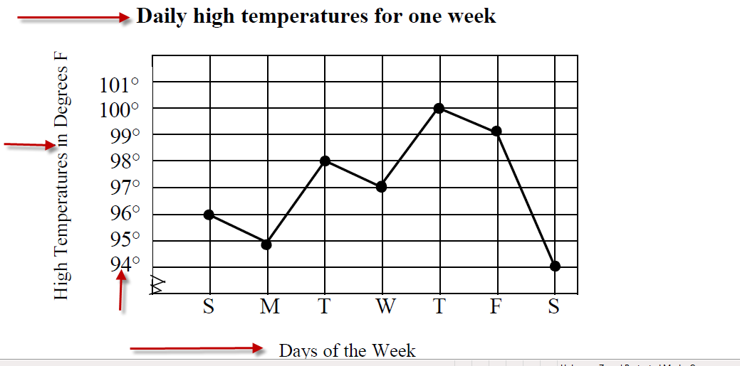
Results (or Data Collection)
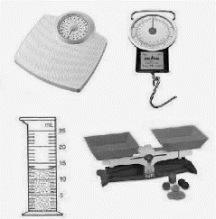
(approximately one page) Present your results thoroughly using graphs, charts, tables, or a daily log to help the reader understand what you have discovered. All the data you collect should also be HANDWRITTEN in your PROJECT DATA BOOK/Journal as your original data.

Here is your chance to show what happened during your experiment. Once you have completed you experiment and have finished collecting data, take your data and make it easily understandable. You can use graphs, charts, or tables – whichever is appropriate to show your results. It would be best to use a computer to help generate your results- the end result tends to be neater. If you do not have a computer, make your display neat and attractive. Use rulers to draw boxes or axis. Color is good also as long as it does not take away from being able to read the data

Title

Axis Label

Incremental

Axis Label
Sample page 5

Discussion (Experimental Conclusion)

In the last section (Results), you SHOWED us the data. Now we want you to DISCUSS your data in words. (Conclusion of your lab work)

(approximately one page) The discussion, or interpretation of results, is the essence of your paper. What could have caused these results? Compare your results with theoretical values, published data, commonly held beliefs, and/or expected results. Include a discussion of possible errors. Other questions you may want to consider:
  - How did the data vary between repeated observations of similar events?
  - How were your results affected by uncontrollable events?
  - What would you do differently if you repeated this project?
  - What other experiments should be conducted?

Sample page 6

This paragraph gives a quick summary of the background research.
Summary of entire paper!

Conclusion

This process of warm air rising and cold air falling keeps the air moving and helps carry pollution away from it source. A thermal inversion occurs when hot air is above colder air. Hot air rises and cold air falls. If the cold air is nearer to the ground, there will be no mixing of air. This “still” air has no wind to carry away the pollution particles. A thermal inversion traps air near the ground.

My hypothesis proved incorrect. I predicted that the hot air smoke would not rise out of the bottle. Instead, it would be trapped near the ground (stay in the bottom of the bottle) and the cold air would rise. I also predicted that a thermal

inversion would have no effect on the air pollution at all.
Includes the actual data from the experiment to tell what was learned.
Restates hypothesis and tells whether it is correct or not.

In doing my experiment, I observed that the cold air smoke stayed in the bottom of the bottle for a long time before it disappeared. At no time did it rise to the top. I was so sure that the hot air smoke would not rise; instead it would stay in the bottom of the bottle. However, it seemed like once I dropped the match into the bottle with the hot air smoke, I saw the smoke rise up to the top of the bottle and then it quickly disappeared. I did this experiment six times. Each time I got the same results. The only problem I remember was that sometimes the match would go out before I could get it to the bottle. I think this happened because I was scared of the fire. I was afraid I might get burned, but my mom said she wouldn’t let that happen.

Mentions problems that occurred during the experiment.
Repeated trials

I’d like to try this experiment with a watch instead of a timer. I could check
the bottles every minute to see if there
Discusses changes that could be made if
the experiment was done again.

the amount of smoke in them or not.
was smoke in

Sample page 7

Bibliography
A minimum of 5 sources with 3 being books: (Elementary: 3 sources with 1 being a book)(Sometimes called "Works Cited.") List all books, encyclopedias, journal articles, web sites, etc., you used. Different disciplines often follow different referencing formats; check an article from a scientific journal in your field if you want perfection, but most importantly, be consistent! Wikipedia is not a reliable source. See “The Parts” page 13-14 for more detailed information.
Notice the sources are listed in alphabetical order by
author’s last name.

Bender, David and Leone, Bruno. The Environment Opposing View Points. San Diego: Greenhaven Press Inc., 1996.

Brower, Michael and Leon, Warren. The Consumer’s Guide to Effective Environmental Choices. New York: Three Rivers Press, 1999.

Chandler, Gary and Graham, Kevin. Protecting Our Air, Land and Water. New York: Henry Holt and Company Inc., 1996.
There is no author name, so it is listed alphabetically
by title.
Current Controversies: Pollution. San Diego: Greenhaven Press Inc., 1994.

Ehrlich, Anne H. Betrayal of Science and Reason. Washington, D.C.: Island Press, 1996.

McCormick, John. Acid Rain. New York: Gloucester Press: 1991.

Morgan, Sally. The Ozone Hole. Danbury: Franklin Watts, 1996. Copyright date

Redalia, Debra Dadd. Sustaining the Earth. New York: Hearst Books, 1994.

Rybolt, Thomas R. and Mebane, Robert C. Environmental Experiments About Air. New Jersey: Enslow Publishers Inc., 1993.

Book title is underline

Stille, Darlene R. Air Pollution. Chicago: Children’s Press, 1990.

Sample page 8

Abstract
This brief (250-word maximum) summary should include the (a) purpose of the experiment, (b) procedures used, (c) data, and (d) conclusions. It should be on a separate page with the title of the project at the top. (Do not put your name on this sheet.) See any scientific journal article for an example of an abstract.

Almost all scientists and engineers agree that an abstract should have the following pieces in separate paragraphs:
  - Purpose of the experiment - This is where you describe the purpose for doing your science fair project or invention. Identify the problem you solved or the hypothesis you investigated. Why should anyone care about the work you did? You have to tell them why. Did you explain something that should cause people to change the way they go about their daily business? If you made an invention or developed a new procedure, how is it better, faster, or cheaper than what is already out there? Motivate the reader to finish the abstract and read the entire paper or display board.
  - Procedures - What was your approach for investigating the problem? Don’t go into detail about materials unless they were critical to your success. Do describe the most important variables if you have room.
  - Data - What answer did you obtain? Be specific and use numbers to describe your results. Do not use vague terms like “most” or “some”.
  - Conclusions -State what your science fair project or invention contributes to the area you worked in. Did you meet your objectives? Was your hypothesis supported?

Sample page 8

End of
Sample Research Paper

